CONFIDENTIAL HEALTH HISTORY QUESTIONNAIRE

COMPASSIONATE ACUPUNCTURE AND HEALING ARTS
Barbara Connor, M.Ac., L.Ac. and John G. Connor, M.Ac., L.Ac.
4501 Valley Forge Road, Durham, NC27705
Phone (919) 309-7753 Fax (919) 309-7753
Date:_________________________
Name:________________________ Phone: (Home)____________________________
Phone (Work)__________________ Phone: (Cell)______________________________
Address:___________________________________ City:_______________________
State______Zip_________ E-mail:__________________________________________
Age:_______ Date of birth__________ Occupation.:___________________________
Employer's name:________________________________________________________
Full time:___ Part time: ___ School: ___ Retired: ___ Unemployed: ___ Other: ___
Support activities/pursuits/groups: ____________________________________________
Living Situation: Alone: ___ Friends: ___ Spouse: ___ Partner: ___ Parents: ___ Children: ___
Name of Partner/Spouse: ___________________________________________________
In emergency notify: ____________________ Phone: ____________________________
Referred by: _____________________________________________________________
Main health issues you would like to address at this time : ____________________________________________________________________
________________________________________________________________________
CANCER INFORMATION (This section to be filled out by cancer patients only.)
Have you ever been diagnosed with cancer, a mass or a tumor? Yes: __No: __When: ___
Location: __________________________ Type: _______________________________
Current status (eg. post surgery, recurrence, etc.): ________________________________
Current Stage: _______________ Relevant Tumor Markers: ______________________
CONVENTIONAL CANCER TREATMENT HISTORY
Date Surgery Chemotherapy Radiation Dose Duration
___________________________________________________________________________________
___________________________________________________________________________________
___________________________________________________________________________________
If you are in a clinical trial or experimental protocol please provide details: _____________________________________________________________________
CURRENT/RECENT HEALTH CARE PROVIDERS (Surgery, Oncology, Primary Care)
Name Dates Care Provided
___________________________________________________________________________________
___________________________________________________________________________________
___________________________________________________________________________________
FAMILY HISTORY
Please include any of the following: Alcoholism, high blood pressure, cancer,
diabetes, heart disease, osteoporosis, other addiction or illness.
Member Still Living Age Diseases Causes of death Age at Death
Mother________________________________________________________________________
Father_________________________________________________________________________
Siblings_______________________________________________________________________
Siblings_______________________________________________________________________
Maternal Grandmother____________________________________________________________
Maternal Grandfather ____________________________________________________________
Paternal Grandmother____________________________________________________________
Paternal Grandfather_____________________________________________________________
PERSONAL HISTORY
Please check if you have had or have at present any of the following:

Allergies ____ Asthma _____ Arteriosclerosis____
Arthritis _____ Artificial Joints_____ Crohn’s _____
Chronic Cough _____ Chronic Diarrhea _____ Colitis ______
Diabetes_____ Diverticulitis _____ Hepatitis A _____
Hepatitis B ____ Hepatitis C _____ HIV/AIDS_____
Kidney Stones____ Liver Disease___ Lupus _____
Lyme Disease____ Mononucleosis ____ Pacemaker ___
Parasites _______ Seizures /Epilepsy___ Stroke____
Thyroid Disease___ Ulcer _____ Venereal Disease ____
Have you been treated by acupuncture or Oriental medicine before? ____________

HOSPITALIZATIONS / SURGERY (NON CANCER)
Date Hospital Diagnosis/Operation Doctor
_______________________________________________________________________
________________________________________________________________________
________________________________________________________________________
________________________________________________________________________

ACCIDENTS / INJURIES Briefly Describe:
More than 5 years ago _________________________________________________

Less than 5 years ago__________________________________________________
Height______Weight______Blood pressure: _____ Skin: Dry ___ Oily ___Normal___

Birth history (prolonged labor, forceps delivery, etc): _________________________
Please rate the following on a scale of 1 to 10 (10 being the best) - write any comments
Sleep___________________________ Energy Level ____________________________
Appetite _________________________ Digestion ______________________________
Do you rely on any of the following for bowel elimination? (Yes or No) Enemas _____
Laxatives _____ Purgatives _____ What type or brand? ________________________
Name & Brand of Current Supplements or Herbs Dosage Frequency
_______________________________________________________________________
_______________________________________________________________________
_______________________________________________________________________
_______________________________________________________________________
_______________________________________________________________________
_______________________________________________________________________
_______________________________________________________________________
_______________________________________________________________________
_______________________________________________________________________
_______________________________________________________________________
Name of Medication What it is for? Dosage Frequency___
_______________________________________________________________________
_______________________________________________________________________
_______________________________________________________________________
_______________________________________________________________________
_______________________________________________________________________
_______________________________________________________________________
_______________________________________________________________________
_______________________________________________________________________
Medications or herbs you have allergies to: _____________________________________________________________________
Occupational stress (chemical, physical, psychological, etc.): _____________________________________________________________________
Have you ever been exposed to pesticides, toxic chemicals, heavy metals, radiation, or
other toxins beyond those encountered in daily life?___m__________________________
Do you have a regular exercise program? Yes ____ No ____ What kind? _______________________________________________________________________
Have you been or are you on a restricted diet? Yes____ No ___ What kind? ________________________________________________________________________
Please describe your average daily diet:
Breakfast: __________________________________________________________________
__________________________________________________________________
Lunch: __________________________________________________________________
__________________________________________________________________
Dinner: __________________________________________________________________
__________________________________________________________________

How many cigarettes do you smoke per day? ________
How much coffee, tea or cola do you drink per day? (Specify) ________________
How much alcohol do you drink per week? _______
Please describe any use of drugs for non-medical or recreational purposes: __________________________________________________________________
PLEASE CHECK ANY YOU HAVE HAD IN THE LAST YEAR
GENERAL
__ Chills __ Fevers __ Sweat easily
__ Night sweats __ Localized weakness __ Bleed or bruise easily
__ Peculiar taste or smells __ Strong thirst (cold or hot) __ Thirst, no desire to drink
__ Fatigue __ Sudden drop in energy - At what time of day? ______
__ Edema __ Poor sleep __ Tremors
__ Cravings __ Change in appetite __ Weight gain
__ Weight loss Other_______________________________________

SKIN & HAIR
___Rashes __ Itching __ Change in hair or skin
__ Ulcerations __ Eczema __ Oozing from skin lesion
__ Hives __ Pimples __ Recent moles
__ Loss of hair __ Dry skin ___ Cracked Nails
Other: ____________

HEAD, EYES, EARS, NOSE AND THROAT
__ Dizziness __ Facial pain __ Migraines
__ Headaches When? ______________ Where? _________________
__ Poor vision __ Blurry vision __ Color blindness
__ Blind field __ Spots in front of eyes __ Eye pain
__ Eye strain __ Cataracts __ Eye dryness
__ Excessive tears __ Discharge from eyes __ Poor hearing
__ Ringing in ears __ Earaches __ Discharge from ear
__ Nose bleeds __ Sinus congestion __ Teeth grinding
__ Teeth problems __ Concussion(s) __ Recurrent sore throats
__ Hoarseness __ Sores on lips or tongue Other: ______________

CARDIOVASCULAR:
__ High blood pressure __ Low blood pressure __ Chest discomfort/pain
__ Heart palpitations __ Cold hands or feet __ Swelling of hands
__ Swelling of feet __ Blood clots __ Fainting
__ Difficulty breathing Other cardiovascular problems: ___________________

RESPIRATORY:
__ Cough __ Asthma/wheezing __ Pain with a deep breath
__ Difficulty in breathing when lying down __ Coughing blood
__ Production of phlegm What color? ___________ __ Bronchitis
__ Pneumonia Other lung problems: ____________________________

GASTROINTESTINAL:
__ Nausea __ Vomiting __ Heartburn
__ Belching __ Indigestion __ Diarrhea
__ Constipation __ Chronic laxative use __ Blood in the stools
__ Abdominal pain/cramps __ Gas __ Rectal pain
__ Hemorrhoids Other stomach or intestinal problems: _____________

UROGENITAL:
__ Pain on urination __ Urgency to urinate __ Frequent urination
__ Blood in the urine __ Decrease in flow __ Unable to hold urine
__ Dribbling urine __ Impotency __ Change of sexual desire
__ Sores on genitals __ Night-time urination How often? _______________
Color of urine: _______ Other urogenital problems: _______________________

GYNECOLOGY AND PREGNANCY:
Number of pregnancies __ Number of births __ Premature births __
Miscarriages __ Abortions __ Age at first menses ______
Days between menses __ Length of periods __ First date of last menses __
__ Unusual character (light or heavy) __ Painful periods
__ Irregular periods __ Changes in body/psyche prior to menstruation
__ Clots __ Menopause at age __ __ Vaginal discharge
__ Vaginal sores Last Pap ____________ __ Breast lumps
__ Practice birth control What type and for how long?_____________________
__ PMS symptoms Please describe: _________________________________
NEUROPSYCHOLOGICAL:
__ Seizures __ Area of numbness: Where? __________________
__ Weakness __ Sleep disorder __ Poor memory
__ Bad temper __ Loss of control/violence potential
__ Depression __ Anxiety __ Easily susceptible to stress
__ Vertigo __ Loss of balance __ Lack of coordination
__ Muzzy headedness/lack of clarity __ Substance abuse
Have you every been treated for emotional problems? Yes __ No __
Have you ever considered or attempted suicide? Yes __ No __
Other neurological or psychological problems: _______________________________

MUSCULOSKELETAL:
__ Neck pain __ Shoulder pain __ Back pain
__ Elbow pain __ Hand/wrist pain __ Hip pain
__ Knee pain __ Foot/ankle pain __ Muscle pains
__ Muscle weakness __ Heaviness in the limbs
Other musculoskeletal problems: ____________________________________________
Refer to the drawing below and please indicate painful or distressed areas on it__________________________________________________________________
How would you rate your pain levels on a scale of 0 - 10 ( 10 being worst pain level)___________________________________________________________________
How would you rate the frequency of the pain in these areas _______________________
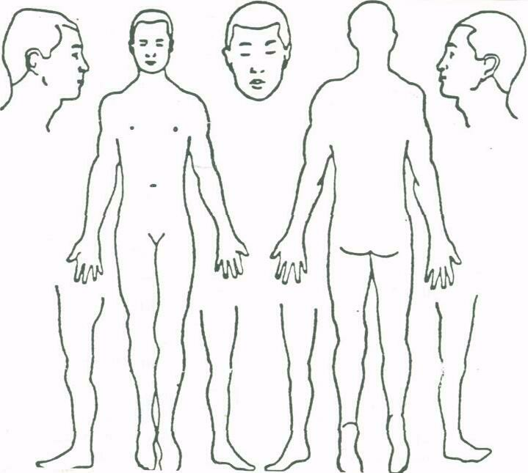
Please note: You will be charged the full fee for missed appointments without 24 hours advance notice.
Free Daily Email Health Newsletter. ____ Yes, I would like to receive this.
____ No, I prefer not to receive this.

